Unit Testing Report – Melvin Chavara (s5290581), Adithya Srinivas Bellamkonda(s5295811)  
loadDataFunction

buttonTestFunction:  
  
buttonTest.py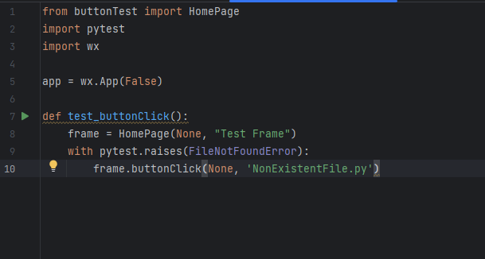

testButtonFunctions.py

pyTest for buttontest:

SuburbListingFunctionTest:

**Valid Suburb Input:**  
validSuburbInputTest.py

TestValidSuburbInput.py

pytest of testValidSuburbInput:  
